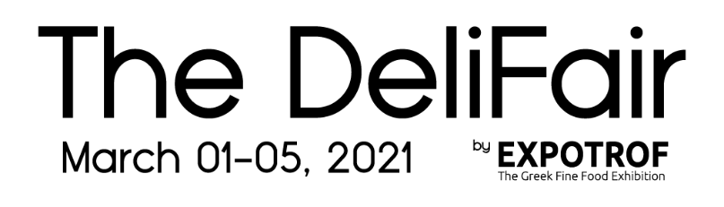
Partner ID
DF2021

Buyer Application– The DeliFair by EXPOTROF, Greek virtual Trade Show
Dates: 1-5 March, 2021

Company Name:

Country:

Company Type:

Retailer: Distributor: Horeca: E-commerce: Other (please list)

Web-site:

Phone number:

Company Profile:

Attendee Name 1 _______________________________________

Function: Phone:

Cell: Email:

Categories interested to review:

Dairy Products Cheese Products Eggs Meat and Meat products

Fish and Seafood Bakery & Confectionery Honey & Bee Products

Olive oil & Olive products Health & Wellness Products Delicatessen Products

Wine, Distilled & Vinous products Beverages, Juices & Water

Organic Products Greek Traditional Deserts Mastiha Products Truffle Products

Aloe Vera Products Cannabis Products Other

Attendee Name 2 _______________________________________

Function: : Phone:

Cell: Email:

Categories interested to review:

Dairy Products Cheese Products Eggs Meat and Meat products

Fish and Seafood Bakery & Confectionery Honey & Bee Products

Olive oil & Olive products Health & Wellness Products Delicatessen Products

Wine, Distilled & Vinous products Beverages, Juices & Water

Organic Products Greek Traditional Deserts Mastiha Products Truffle Products

Aloe Vera Products Cannabis Products Other

I hereby declare that I have been informed and Ι explicitly accept with no reservations whatsoever and in binding on the aforementioned company, that by the start of the exhibition we will have taken all the necessary measures and precautions to provide available and responsible company person(s) to carry out all the appointments - online meetings that will be requested by or determined with the exhibitors of thedelifair.gr during the days of the exhibition and during the hours that will be set as available in our digital calendar on the exhibition platform, which we agree that cannot be fewer than two (2) hours of availability per exhibition day. It is also agreed that cancellations of scheduled appointments can take place no later than 10am of the appointment day. It is understood that in any other case the company can and will be held liable for any damages caused to the Organizer of thedelifair.gr or any third party due to our above actions or omissions.

