To proceed with your visa application, please complete the following information:
- First Name:
- Last Name:
- Father’s Name:
- Nationality:
- Passport Number:
- Type of Passport:
☐Ordinary
☐Service
☐Diplomatic
☐Travel Document
☐Laissez-Passer
☐Official
- Company/Organization Name:
- Position:
- Address:
- Email:
- Telephone Number:
- Mobile Number:
- Marital Status:
- Number of Previous visits to Iran:
- Date of Entry (dd/mm/yyyy):
- Date of Departure (dd/mm/yyyy):
- Detailed Travel Itinerary:
- Place of stay during visit:
- Recent Passport-sized Photo (see requirements below):
- Copy of Passport (see requirements below):
- Place of Visa Collection (choose ‘Place of Issue’ within the following link: https://evisatraveller.mfa.ir/en/request/applyrequest/)
(For your convenience, we advise against selecting Imam Khomeini International Airport (IKA) as the place of visa collection, as this option may result in delays upon arrival. Nevertheless, it remains permissible to indicate this location if deemed necessary.)

Photo Requirements
https://evisatraveller.mfa.ir/en/request/digital_image_requirement/?title_name=photo
Your photo is a vital part of your visa application. To learn more, review the information below on how to provide a suitable photo. The acceptance of your photo is at the discretion of the I.R.Iran Embassy or consulate where you apply.
We recommend you use a professional visa photo service to ensure your photo meets all the requirements. Please remember that photos must not be digitally enhanced or altered to change your appearance in any way.
Your passport photos must be:
- In color
- In JPEG (.jpg or .jpeg) file format
- Equal to or less than 500 kB (kilobytes) in file size (less than 10 kB is not accepted)
- In a rectangular aspect ratio (height must be greater than width)
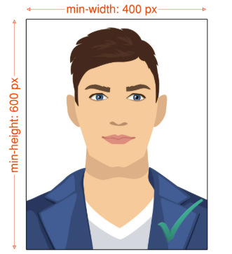
- Be sized in 400 (minimum-width) x 600 (minimum-height) pixels, with about 70-80% part of the photo must be filled by the applicant’s face
- Taken within the last 6 months to reflect your current appearance
- Taken in front of a plain white or off-white background
- Taken in full-face view directly facing the camera
- With a neutral facial expression and both eyes open
- Taken in clothing that you normally wear on a daily basis
- Uniforms should not be worn in your photo, except religious clothing that is worn daily.
- Do not wear a hat or head covering that obscures the hair or hairline, unless worn daily for a religious purpose. Your full face must be visible, and the head covering must not cast any shadows on your face.
- Headphones, wireless hands-free devices, or similar items are not acceptable in your photo.
- Eyeglasses are not allowed in visa photos, except in rare circumstances when eyeglasses cannot be removed for medical reasons; e.g., the applicant has recently had ocular surgery and the eyeglasses are necessary to protect the applicant's eyes. A medical statement signed by a medical professional/health practitioner must be provided in these cases. If the eyeglasses are accepted for medical reasons:
  - The frames of the eyeglasses must not cover the eye(s).
  - There must not be glare on eyeglasses that obscures the eye(s).
  - There must not be shadows or refraction from the eyeglasses that obscures the eye(s).
- Photos digitally scanned from driver’s licenses or other official documents are not acceptable. In addition, snapshots, magazine photos, low quality vending machine or mobile phone photos, and full-length photographs are not acceptable.

Change of Appearance
If your photo(s) or digital image does not reflect your current appearance, even if it is not older than 6 months, the I.R.Iran Embassy or consulate will request that you provide a new photo with your application.
Applicants will be requested to obtain a new photo if they have:
- Undergone significant facial surgery or trauma
- Added or removed numerous/large facial piercings or tattoos
- Undergone a significant amount of weight loss or gain
Generally, if you can still be identified from the photo in your visa application, you will not need to submit a new photo. For example, growing a beard or coloring your hair would not generally be considered a significant change of appearance.
If the appearance of your child under the age of 16 has changed due to the normal aging process, he or she will generally not have to provide a new photo. However, the acceptance of your photo or digital image is at the discretion of the I.R.Iran Embassy or consulate where you apply.

Taking photos of your baby or toddler
When taking a photo of your baby or toddler, no other person should be in the photo, and your child should be looking at the camera with his or her eyes open.
Tip 1:
Lay your baby on his or her back on a plain white or off-white sheet. This will ensure your baby's head is supported and provide a plain background for the photo. Make certain there are no shadows on your baby's face, especially if you take a picture from above with the baby lying down.
Tip 2:
Cover a car seat with a plain white or off-white sheet and take a picture of your child in the car seat. This will also ensure your baby’s head is supported.

Passport Copy Requirements
https://evisatraveller.mfa.ir/en/request/digital_image_requirement/?title_name=passport
The digital image of your passport is a vital part of your visa application. To learn more, review the information below on how to provide a suitable digital image. The acceptance of your passport copy is at the discretion of the I.R.Iran Embassy or consulate where you apply.
We recommend you use a professional visa photo service to ensure digital image of your passport meets all the requirements.
Your digital image of your passport must be:
- In color
- In JPEG (.jpg or .jpeg) file format
- Equal to or less than 500 kB (kilobytes) in file size (less than 10 kB is not accepted)
- Only the first page. full-length images are not acceptable.
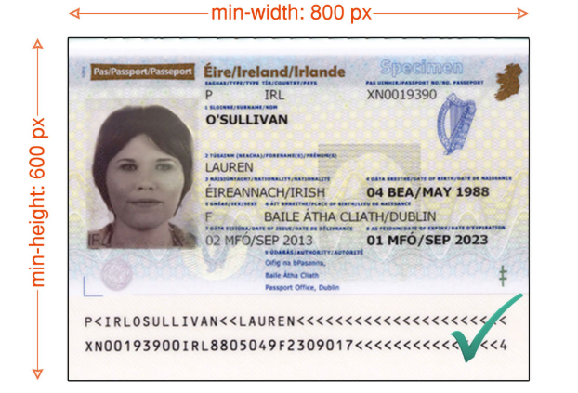
- In a rectangular aspect ratio (height must be less than width). Be sized in 800 (minimum-width) x 600 (minimum-height) pixels
- Sharp without any visible pixels
- properly exposed (too dark or light is not acceptable)
- In a right position.
- Clear and all characters must be readable.

